Deployment Of App in IBM Cloud

Upload image to ibm container registry

(Customer Care Registry_PNT2022TMID52279)

Step-1

Login with ibm.com ,search with container registry in search catalog

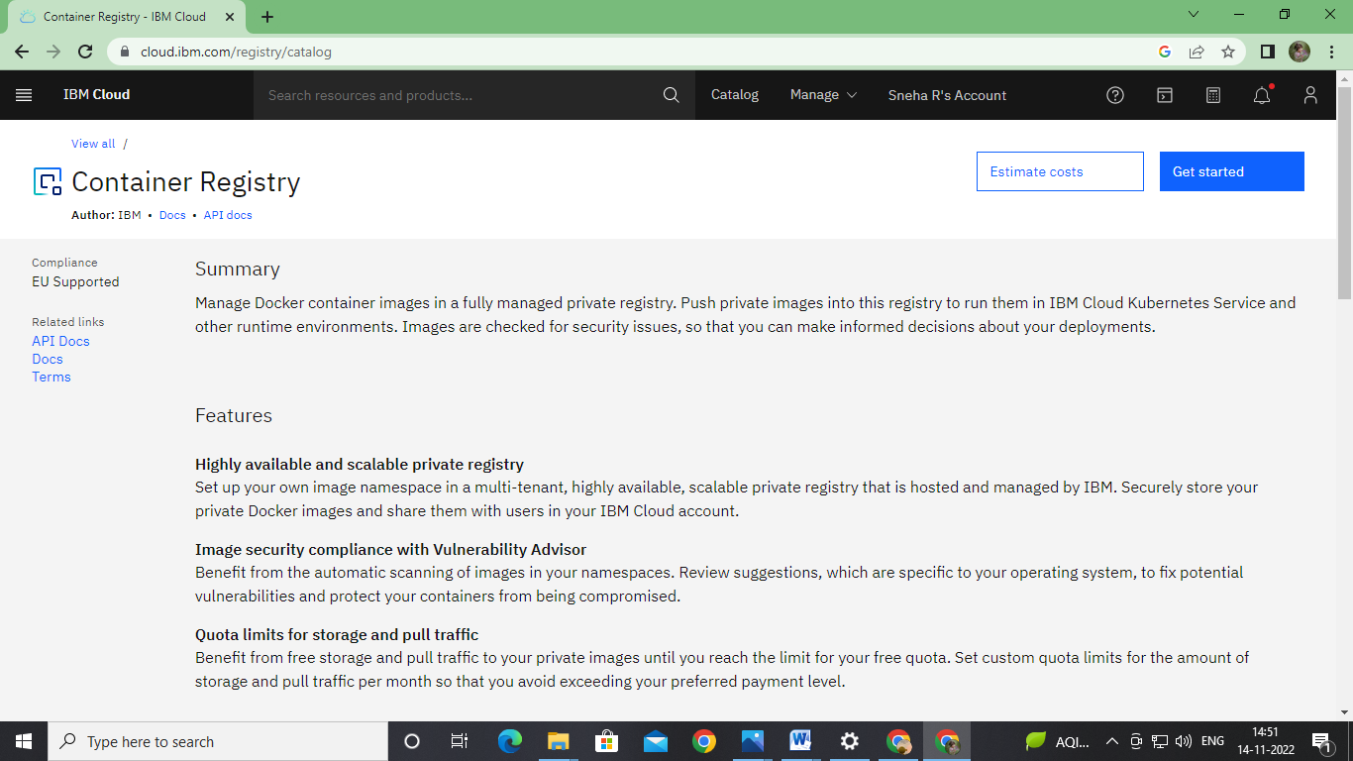

Step 2

Imported the image in the container registry using following commands

